Ten Years Ago: Murderball

Date: July 16, 2015
Author: Marcus Gorman
Source: https://tenyearsago.wordpress.com/2015/07/16/ten-years-ago-murderball/

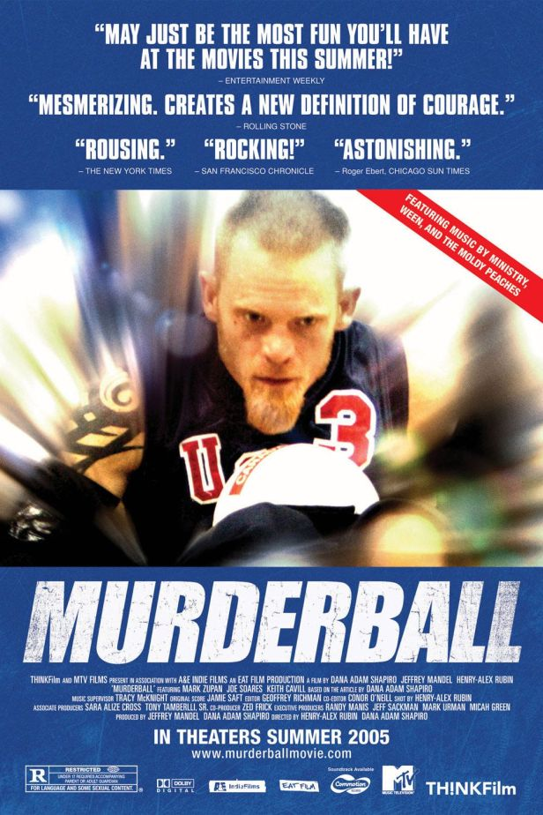

I’ve spent the past two or three months doing nothing but reading and writing about disability theory for my dissertation, so I thought, sure, let’s re-view Murderball, the 2005 documentary about the U.S. Quad Rugby Team and their quest to win the gold at the 2004 Paralympic Games.

I’ve recently been writing a lot about representations of disability and grappling with how certain representations of disability reinforce the ideology of ability, while others seek to unravel it. Murderball, as a film, does a little of both.

It is most certainly made for a non-disabled audience. The opening shot of the film shows rugby player Mark Zupan disrobing. The camera lingers on Zupan pulling off his bed clothes to put on his workout gear, all while sitting in his chair. It focuses of Zupan taking off his pants to reveal his legs, which one might describe as atrophied as a result of his paralysis. There’s no sound playing over the scene. It seems distant and clinical. It is as though the audience is a doctor observing a patient, and it assumes that the relationship is one of an able-bodied observer studying a patient with a disability.

But this opening shot also establishes that this film won’t spend all of its time replicating this uncomfortably medical gaze when it holds focus on Zupan’s tattooed leg. One of his calves is nearly entirely covered in a black tribal design. We never get an answer in the film as to whether Zupan got this tattoo before or after his accident, but either way the tattoo reinforces his toughness, his masculinity. (Either he was badass enough before the accident to withstand the pain of a calf tattoo, or he has badass enough after the accident to spend four hours joking with a tattoo artist about whether or not he could feel anything happening at all.) The tattoo lets us wonder about Zupan. It seems unexpected on a disabled body and therefore allows an able-bodied audience to read Zupan as a person, rather than a patient or a case file.

Murderball spends most of its time treating the rugby players like athletes, which are the parts of the film I really like. I love watching the shots of the guys at practice, or in competition, and hearing them talk strategy about the game. The film’s primary narrative tracks the US team’s relationship with its former coach Joe, a former paralympian who defected to coach the Canadian national team after he was fired from Team USA in the late 1990s. I like knowing that the U.S. Quad Rugby Team won all 11 international wheelchair rugby competitions up to the time of filming. And I especially like knowing that the game of wheelchair rugby (or “murderball,” as it used to be called) is designed to account for individual experiences of disability. Because quadriplegics are classified differently depending on where the spine was broken (which determines mobility), quad rugby players are each assigned a point value based on their level of mobility. More mobile players have higher point values (Zupan is a 3-point player in the film), and less mobile players have lower point values. A team cannot put more than 8 points in play at any time so that each team has a balanced level of abilities on the court, and so that all players are guaranteed court time, regardless of their level of mobility. The game recognizes that experiences of disability are individual, and all of those experiences can make of a valuable athlete. I find the game of quad rugby itself, and the narrative about athletic competition, to be the parts of this film that work against the ideology of ability because it shows disabled people as capable, adaptive, and valuable human beings. (The U.S. Team takes the bronze at the 2004 Paralympics. Canada takes the silver, and New Zealand comes from behind to take the gold.)

But there are other aspects of the film that don’t do much to counteract a preference for able-bodiedness. In order to satisfy the medically trained curiosity of an able-bodied audience, the filmmakers choose to interview each athlete to describe what I’ll call the “How I Got in This Chair Story.” The chair stories, on the one hand, show that disability is a fluid state that any person could arrive in at any time, which does some work to rethink what disability means, but they also draw on audience pathos in ways that are meant to make able-bodied viewers feel sorry for the quad rugby players, and then be inspired by them when we see them do athletic things. The chair stories make the bodies of the quads intelligible to the audience, reassuring able-bodied viewers that they’re fortunate to not be the guys in those chairs. During the telling of each chair story, the filmmakers show “before” photos of the men as children or teenagers, standing upright on two legs. These images are troubling because they reinforce the narrative of disability as decline.
Interestingly, the chair stories in Murderball also serve another function: they produce disabled masculinity, which really is the core of what the film expresses as a whole. Disabled masculinity is a hyperstylized performance that seems compensatory by design. I call these performances compensatory because the rugby players are shown throughout the film to be participating in masculine behavior: playing poker, drinking, talking about sex, playing sports, etc. But these men perform their masculinity in overt and exaggerated ways, which seems to frame the performance of their gender identity as compensating for their physical bodies. The chair stories aid in the development of this kind of masculinity. With the exception of Coach Joe and the team’s one quad amputee, all of the U.S. quad rugby players became disabled as the result of an accident associated with masculine behavior. While Joe and the amputee became wheelchair users due to childhood illnesses (polio and meningitis, respectively), every other member of Team USA became disabled after a fist fight or a car accident (usually after a night of drinking) or some other accident involving an extreme sport (i.e. motocross, motorcycle racing, etc). The craftsman who makes the customized chairs for the rugby court calls his creations “Mad Max Wheelchairs.” His alignment with the hypermasculine post-apocalyptic car-modding franchise is not an accident, as the cars in Mad Max are also external signifiers of masculine power. So, too, are the murderball chairs.
Further, the filmmakers devote an entire section of the film to how these men handle relationships with other people. The players comment about rejecting help when kind strangers offer it. I don’t deny that strangers offering to help persons with disabilities in public spaces is an ableist response, but it also bespeaks a desire for kindness and empathy that social justice models preach. The players’ rejection of this assistance is well within their rights, but they frame it as an affront to common sense and their own ability to complete tasks, as personal, rather than a cultural precedent. They actively provoke fights at bars, noticing how other men shy away from getting in fights with them. “What? You’re not gonna hit a kid in a chair?” one player relays, “Hit me. I’ll hit you back.” These incidents, coupled with the way the men describe their relationships with women, demonstrate that this particular group of disabled men seems to compensate for their disability by overperforming masculinity.

This tends to work out in their favor when it comes to sexual and romantic relationships. As one player observes, “Women are not threatened by the guy in the chair.” So girls will come up to them in bars and mercilessly flirt, driven by the curiosity of what it would be like to fuck a guy in a chair. All of the players note that all flirtatious interactions they have with women eventually arrive at the question of whether or not their dicks work. Mark Zupan’s girlfriend, Jess, relays that she thinks girls are attracted to quad guys because it allows them to fulfill their mothering instincts. While disabled/non-disabled relationships do certainly require caregiving (as do any romantic relationships, by the way), Jess’ framing of her relationship with Zupan as fulfilling a mothering instinct is problematic. Perhaps without meaning to, Jess is infantilizing her boyfriend, suggesting to the able-bodied viewer that he cannot function in a romantic relationship in the same way as an able-bodied adult man. Her framing, of course, stands at odds with Zupan’s own declaration of his sexual prowess. “People ask how we do it,” he says. “I’ll tell you this: guys in chairs usually love to eat pussy.”

The film discusses each player learning to become sexually active again after their accidents, and I found this portion of the film to be really well handled. Rather than infantilizing these men or treating their sexuality as curiosity (which the players’ stories about girls in bars demonstrate), their honest and frank discussions of what it was like to masturbate for the first time with new hand mobility or the first time they had sex as a quad or what positions they prefer felt like the men were being fully humanized and understood as people, rather than medical subjects. Of course, these discussions of sex also reinforce their virility and masculinity, a la Zupan’s comment about eating pussy. I highly doubt there would be a similar discussion in a film about quad women, as women are expected to be passive sexual partners, not active ones. By talking about sex, the rugby players reclaim their status as active sexual partners in the eyes of able-bodied viewers, who read their disability as lack.
Murderball’s secondary narrative is the story of Keith, a new quadrupalegic, going through rehab, learning how his new body works, and discovering murderball. As Keith is introduced, his mother says of his motocross accident, “His whole life has been on wheels. Now one of Keith’s favorite things hurt him.” Keith’s mom apparently misses out on the fact that her son still gets to be on wheels—just different ones than before. The filmmakers certainly don’t miss out on the irony of this comment, though, showing a scene of Keith wheeling through the rehab center alongside images of his old motocross days. Keith’s story demonstrates that recovery and rehabilitation is a long process. Even though Keith has only been in the facility for four months before he is released, he talks about other patients post-spinal cord injury who have been there for months. The nurses, whom he likes to flirt with, give him a farewell card that he has difficulty opening. He refuses their help politely when they offer, and the camera lingers on the long process of Keith opening the envelope. On his return home, Keith speaks openly about how upset he is that he can’t use the space in the same was as he could when he wasn’t a wheelchair user. His mother tries to remind him that he’ll adjust, and Keith tells her that he knows he will, be he can still be mad about it. Keith meets Mark Zupan at the rehab center when Zupan comes to talk about the Paralympics. Watching Keith’s eyes light up when he learns about quad rugby is absolutely the best moment of this film.

For me, Keith’s story makes visible that rehab doesn’t magically happen overnight, and that adjusting from able-bodied life to disabled life is difficult because of how entrenched the ideology of ability is in our day to day lived experiences, from the construction of buildings to our social responses. And when Keith learns about murderball, he recognizes that there are things his new body can do that his old body couldn’t, and that’s a really cool moment to witness. Keith is also totally adorable when he asks to test out Zupan’s competition chair, and immediately wants to practice ramming into Zupan. The hospital staff tells him no because of liability, but Zupan lets him give his chair a “love tap” and Keith is hooked. The end titles tell us that Keith is saving up to purchase his first custom murderball chair. Even though Keith’s story is still laced with rhetorical tools that draw the sympathy of the able-bodied audience and reinforce the ideology of ability, I also find his narrative to be really honest and refreshing—perhaps because Keith doesn’t participate in the same compensatory disabled masculinity that the rest of the quad rugby players do. The film constructs him differently: as an individual, rather than a stereotype.
Ten years ago, I likely watched Murderball more like the average able-bodied viewer. I would have found these dudes inspirational, or some iteration thereof. But now, as a disability scholar who is nonetheless able-bodied, I see the films representational contradictions more clearly. To compensate for how they are viewed as disabled, the players and the filmmakers are complicit in constructing these disabled athletes as hypermasculine. This compensatory masculinity is problematic because it makes these rugby players into paragons of what quad men ought to be or do, which undercuts the game’s own emphasis on individual disabled experience. It also, by extension, creates a representational problem for women with disabilities, who become more enfeebled by the invocation of hypermasculinity within disabled representation. The cultural caveat to this, however, is another character from the very franchise invoked in the description of the rugby chairs: Mad Max: Fury Road’s Furiosa.

Furiosa, in 2015, does what Murderball does not: creates a compelling portrait of an amputee without invoking the sensationalist rhetorics of pity/empathy, or using the medical gaze to make her body knowable. Furiosa has no “How I Lost My Arm” story. There are no shots that linger on Furiosa doing things to show that she can do them. She simply does them. She exists as a strong woman in a man’s world, and feels neither the need to act like the hypermasculine war boys (the critically disabled subjects who emerge from such poisonous ideology), nor like the patriarchy’s visions of femininity as depicted in the wives she’s working to free.

In 2015, I really want to see a film about disabled female athletes living their lives without dwelling on the narrative of how they became disabled. The only women in Murderball are Zupan’s girlfriend Jess and Keith’s mother . . . and the few female amputee soldiers at Walter Reed Medical Center in the final shot of the film where the U.S. Team introduces the game to newly disabled soldiers (whose femaleness is subsumed by their identity as soldiers).

And if I’m making a wishlist about how we ought to represent disability, I’d also like to see more representations of disabled people of color. Murderball has one shot of a black quad rugby player. He is presumably on the U.S. team, but we never see him play and the only thing we hear him talk about is his preferred sexual position. Murderball’s representation of disability is limited to hypermasculine, straight, white men, and, while that may also be true of the sport, as a documentary, it tends to support the ideology of ability just a bit more than it works to undo it.
P.S. This documentary is not well made in the aesthetic sense. It looks like a piece of shit. And I think its utter lack of concern for aesthetics aids in its hypermasculine ethos.

P.P.S. Regarding Zupan and his leg tattoo, shortly after Murderball came out, Zupan was a guest on L.A. Ink. He got his other leg tattooed and did, in fact, joke with the tattooist about not being able to feel anything during his session.

