Year 12 ATAR

English

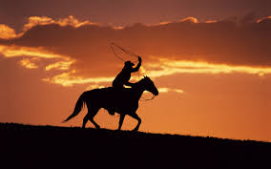

Westerns

Archetypes in the Western Genre

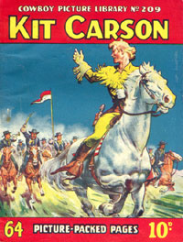
“Peril on the Pony Express” and “Red River Raiders”

When analysing these texts, we need to consider how it is that we are positioned to read the representation of Kit Carson and what it is that his story tells us about archetypes of the Western genre.

It is important to take into consideration the context in which the text was produced, who the texts were produced for and the context we read the text in.

In this sense, the Kit Carson comics were first published during the 1930s and, then, later, during the 1950s. The question for us now is how do these eras impact on the construction of the comics; that is, how do they influence the representation of Kit, Native Americans, women, criminals, the Wild West frontier and civilisation?

One of the critiques of these comics by modern day audiences is that they are farcical, stereotyped and boring. With these critiques in mind, it is necessary to consider very carefully that the reception context – that is the period or era in which we read and ‘receive’ these texts – is very different than the 1930s. Since then, we have seen the rise of the civil rights movement, feminism and the men’s movement. We have experienced war and holocaust and live, more and more, in a world made smaller and faster by technologies of all manner of description. From our context now, the adventures of Kit Carson and, indeed, the man himself seem outdated, a caricature of a long past colonialism that sought to advance civilized people at the expense of those who inhabited the land long before they came.

However, Kit Carson comics do give us a starting point to analyse the genre, they give us a place from which to locate and define the archetypes of the western genre, particularly in regards to character, plot, conflict and symbol.

Archetypal Masculine Traits – The Hero

- Saves the day
- Rescues the injured
- Protects the weak
- Knowledgeable and helpful in all manner of skills
- Loves the dramatic entrance which positions him as separate to the norm – horse speeds in, rears up and ‘presents’ our hero in a heroic and dramatic way.
- Centre of community hope, pillar of morality, he is the focus of the community’s desire to be rescued and saved.
- Brings safety, justice, assurance, security, stability (returns society, through his actions, to peace and harmony)
- Good citizen
- Man of honour – does what’s right because it’s the right thing to do
- Honourable
- Just
- Courageous – puts himself in the line of fire because he must do so to restore order.
- Selfless
- Protector
- Always composed no matter the circumstances.
- Intelligent, intuitive, quick to catch on; he can think on the run.
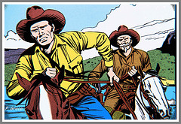
- Quick thinker; problem solver, can detect crime intuitively
- In tune with and in charge of nature
- Often has a faithful companion
- Flawless – emotionless
- Not prone to outburst, panic, fear, loss of control. Never cries or shies away from danger.
- Never shoots first; never hits a smaller man; never takes unfair advantage.
- Trustworthy and Honest – people can trust and rely on is word.
- Gentle with children, women, the elderly and animals.
- Clean in thought, speech, action and personal habits/hygiene
- Patriotic

Archetypal Feminine Traits – The Victim

- Inncocent
- Naive
- Pure
- Wears a dress
- Fertile
- Attractive
- Moral
- Decent
- Quiet
- Victim needing protection
- Incompetent in matters of the world – in matters of the maternal, the domestic and the home she is very competent.
- Damsel in distress – hopeless, powerless, reliant on the hero for her rescue.
- Prone to accident or failure (in conflict situations)
- Becomes a burden, nuisance, a liability to success
- The source of conflict or magnifies existing conflict by ‘getting in the way’
- Often characterised as either the pure and virtuous OR the promiscuous and immoral
- Powerless; belongs to the man; never owns land

Archetypal traits of the Villain – the Indians; the criminal

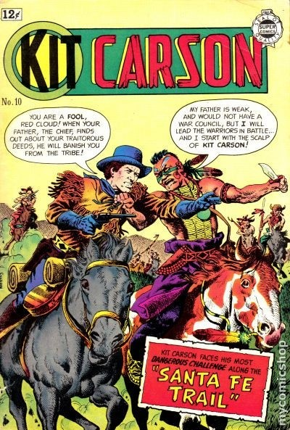
- Uneducated
- Illiterate
- Troublesome
- Ruthless
- Brutal
- Savage
- Uncivilised and barbaric
- Motivated by revenge
- Catogorised – red skins, braves
- Murderous (for no apparent reason)
- Greedy and shallow
- Inhuman and inhumane
- Menace
- Easily manipulated and easily persuaded – gullible, unintelligent, weak-willed, simple, susceptible to greed, succumb to temptation.
- Language always stilted – illiterate.
- Represented in dark, colours, connoting evil, wickedness, danger, uncivilised malice
- Motivated by money, greed, power, control.
- Spineless, weak
- Mexican or of some foreign race (Asian)
- Knows he is a criminal and doesn’t care – he is what he is and there are no other motivations.
- Male

Archetypal Symbols of the Western genre

- Spears, bows and arrows, head-dress
- Stetson hat, rifle (tucked into the saddle)
- Death Dance
- Rain Dance
- ScalpDance
- Smoke signals and beating drums – often connote danger or imminent risk
- Symbolic Indian names – “Smoke-in-the-Sky”
- Forts – the cavalry – soldiers – the cavalry charge – the bugle
- Steamboats
- Covered wagon
- Stagecoaches
- The saloon
- Wig-wams, pow-wows and tee-pees
- Missouri River
- Mississippi River
- Tumble weed
- Brothel
- Gambling
- Stable
- Church (with a steeple)
- White picket houses – son/daughter, wife/husband, dog . . . .the ideal!

Archetypal Plot and Conflicts of the Western plot

- Plot structure moves from order to disorder to reorder. Indians and criminals (bandits) always create disorder and the hero always restores that order by vanquishing the antagonists.
- Order is always seen as civilised, white, Christian, male (patriarchal), and colonial (in favour of the coloniser)
- Cowboy protagonists and Indian antagonists
- The protagonist returns society, through his actions, to peace and harmony.
- The villain is always certain they will ‘get away with the crime’ - the never do because the hero saves the day and good always prevails over evil.
- Christian faith wins out every time against the pagan or the barbarian – all religions other than those which are Christian based, are represented as different, Other and weird.
- Language used to describe the villain and the hero, the masculine and the feminine is very definite, archetypal (Indian – redskin; hero – mighty, woman – scared).
- Conflict – the destabilising of order – is usually quick to happen in the narrative.

Points of Interest

“The Indians” is a collective term that ignores the cultural richness of the many tribes living in America. It is a term that washes away identity, belonging, history, tradition, ritual and many other things that makes each tribe unique.

By giving derogatory names to the Indians, for example “coyotes”, Indians are dehumanised and made no better than a wild animal that needs to be tamed by the white man.

Citizens are conservative, well-dressed, formal proper, wealthy, civilised – the definition of civilised is simply anything other then the wretched Indians.

A hero only exists because villains do. Without the villain, there would ne need to be heroic. The two are entwined in an ironic but reliant relationship.

It is undoubtedly the case that the era in which a text is produced effects its construction – no text is an island. In the 1930s, the world was an anxious place to live. Recovering from the Great Depression and World War one, the world was also dealing with Nazism in Germany, civil war in Spain and China and a genuine fear that a second world war was inevitable. People needed hope, needed to believe that they would be okay and that moral decency, goodness and justice would prevail. They needed heroes.

Into this context comes the technological ability to produce feature length films. In a country such as America, imbued with the a history of the wild west frontier, of battles for civilization, of the quest for freedom and justice, the Western genre becomes a beacon for al that people desire, the heroes they construct (Ringo Kid, Kit Carson) becoming the heroes that people so crave.

It is no surprise then that these heroes, within the narratives they develop, always restore order, peace, justice and hope.

A Selection of Western Images

A still from the film Appaloosa (2009).
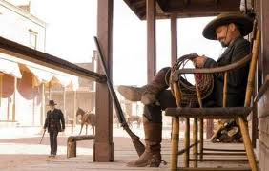
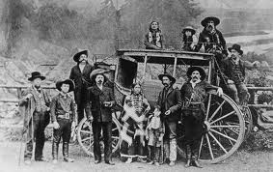

A photograph of Buffalo Bill Cody’s Wild West Troupe. Buffalo Bill (1846-1917) was an American soldier, bison hunter and showman.

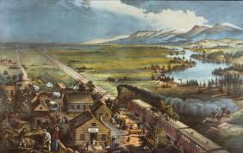

Frances Flora Palmer, for Currier and Ives, Across the Continent: Westward the Course of Empire Makes Its Way, 1868.

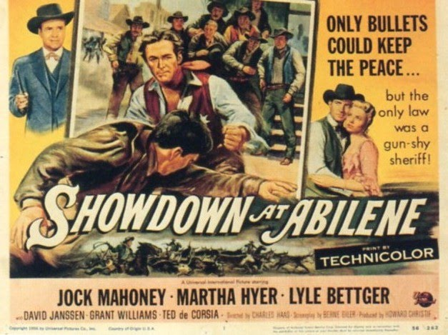A

Film poster promoting the film Showdown at Abilene (1956).
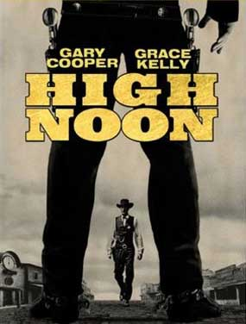

A film poster promoting the film High Noon (1952).

Stagecoach (1939)
Film Overview
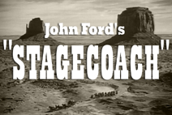
Stagecoach
(1939) - B&W - 96 min
Stagecoach
Starring - John Wayne as the Ringo Kid, Claire Trevor as Dallas, Andy Devine as Buck, John Carradine as Hatfield the gambler, Thomas Mitchell as Dr. Josiah Boone, Louise Platt as Lucy Mallory, George Bancroft as Sheriff Curly Wilcox, Donald Meek as Samuel Peacock Berton Churchill as Gatewood the banker.
Directed by - John Ford
John Ford's 1939 movie, Stagecoach, starring John Wayne as the Ringo Kid is a landmark film. So many movies were made that followed this basic thematic structure, with everyday people who are thrust into an incredible situation and become heroes. The photography is remarkable (Bert Glennon was nominated for an Oscar in Cinematography) and it lost Best Picture honours to David O. Selznik's Gone with the Wind. Thomas Mitchell as Doc Boone won an Oscar as Best Supporting Actor.
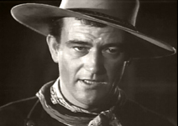
John Wayne as The Ringo Kid

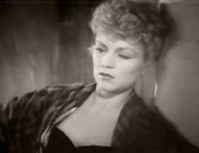
Claire Trevor as Dallas, a saloon girl with a sullied reputation
Part One
Andy Devine is Buck - who drives the stagecoach in the wild, wild west. On this day, the Women's Law and Order League are driving out a few dregs from the town - Doc Boone (Thomas Mitchell), a drunk, and Dallas (Claire Trevor), a saloon gal with a bad reputation. The Apaches, led by Geronimo are on the warpath... so the stagecoach gets an escort from the Union Army.
Part Two
Sheriff Curly rides up front with Buck. In the coach with Doc Boone and Dallas is Sam Peacock (Donald Meek), a whiskey drummer, Lucy Mallory (Louise Platt) , an officer's wife and one of the Law and Order ladies, Gatewood (Berton Churchill), a banker and Hatfield (John Carradine), the gentleman gambler. On the way to Lawrenceville, they meet up with a notorious gunslinger, The Ringo Kid (John Wayne, a.k.a. The Duke). The stagecoach was supposed to meet up with some other soldiers at the next stop - but they are nowhere to be found.
Part Three
The stagecoach moves onward, without the benefit of the Union Army escort. More character development - as the bad guys seem too nice, and the nice folk are a little too civilised. We also learn that Lucy is carrying an extra passenger when Doc Boone delivers her baby. Buck wants to charge her an additional fee.
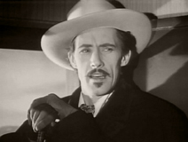
John Carradine as Hatfield, the slick gentleman gambler.

Part Four
The travellers stay a little longer at the Reservation, letting Lucy recuperate from childbirth. We also learn that The Ringo Kid lost his father and his brother to the evil Luke Plummer (Tom Tyler) - who now resides in Lawrenceville. Then we see smoke from the Apaches, which look like war signals.

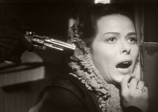
Louise Platt as Lucy Mallory

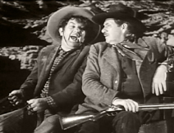
Andy Devine as Buck, the driver and George Bancroft as Sheriff Curly Wilcox.
Part Five
On the final leg of the journey to Lawrenceville it looks like the danger is over. However, it is not! Here we go - one of the greatest scenes in the history of film as Director John Ford pulls out all the stops and shows you why he is considered a master of the medium. Whew! Saved by the Calvery. But now The Ringo Kid is in town, ready to face those nasty Plummer Brothers.
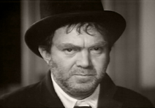
Thomas Mitchell won Best Supporting Actor for his role as the drunken Doc Boone.

Part Six
You will have to watch the conclusion to see how it goes down... but here it is, perhaps the first movie where our heroes ride off into the sunset.
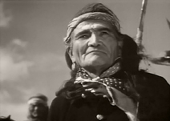
John Ford used real Indians, not the usual Hollywood varieties.

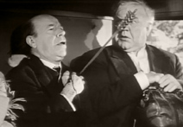
Donald Meek as Peacock and Berton Churchill as Gatewood.

