Responding Section- Comparative Response

Year 12 ATAR English

Question:

Compare the effectiveness of the endings of two texts to position their audiences to respond strongly to their themes or ideas.

The body paragraph which follows would be a continuation from the introduction below:

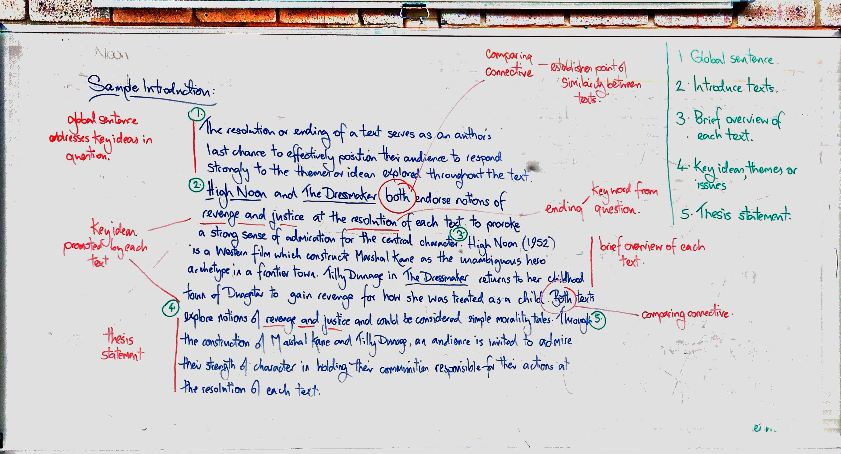

The thesis statement above is as follows:

‘Through the construction of Marshal Kane and Tilly Dunage, an audience is invited to admire their strength of character in holding their communities responsible for their actions at the resolution of each text.’

Remember that an effective topic sentence will build explicitly and clearly from the thesis statement in order to demonstrate a cohesive argument.

Model Body Paragraph

Marshal Kane (played by Gary Cooper) endorses the hero archetype throughout High Noon, but it is at the resolution of the text that our admiration for his character construction is confirmed. Having successfully defended himself (and the townspeople) from the menacing threat of Frank Miller’s gang, his contempt for the townspeople’s failure to help him is very clear. Kane removes his sheriff’s badge and contemptuously throws it on the floor. This is significant for several reasons. Firstly, the badge is symbolic of his status and power, and his actions reject both of these constructs. Having been morally unambiguous throughout the film, Kane’s action demonstrates his willingness to remain true to his values and this also serves to elevate an audience’s admiration for the constancy of his character construct. The lack of dialogue at this point in the film allows the audience to focus on Kane’s values as he rides out of the town with his integrity intact. The resolution of High Noon clearly endorses the importance of Kane’s morality and confirms our admiration for holding the townspeople fully accountable for their actions.

Tilly Dunage in The Dressmaker is constructed as a morally ambiguous character and the resolution of this film provokes a more complex response from the audience. Having already been constructed as a character seeking revenge, her actions invite conflicting responses from the audience. While an audience might be entitled to admire her strength of character in exacting a terrible revenge on those who wronged her, it is also perfectly reasonable to conclude her actions (in reducing the town to ashes) weren’t a proportionate response to how she was treated as a child. The red fabric she rolls down the hill (before setting it alight) from her home is clearly ironic and unifies her character. An audience would associate ‘rolling the red carpet out’ as a welcoming gesture; here, it precedes her pyromania in burning Dungatar to its foundations. It also unifies her character arc as her first public appearance in the film constructs her character as dangerous through the symbolic colour of the red dress she wears at the football match. An audience is left to conclude at the resolution of The Dressmaker that Tilly Dunage has lost none of her danger and we admire (with some reservation) her strength of character.

