Comprehension Style Questions

***
Question 1: Examine how visual conventions are used to challenge traditional representations of soldiers.
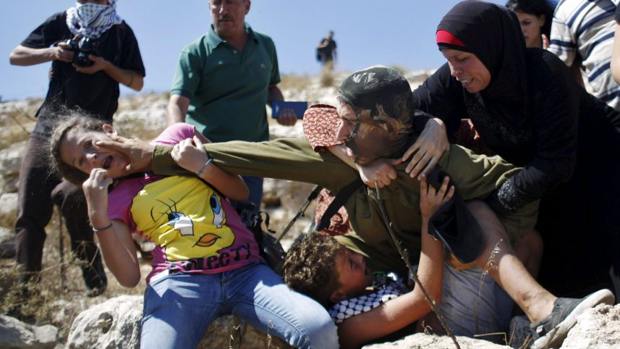

Question 2: Examine how the following text presents particular perspectives of young soldiers.
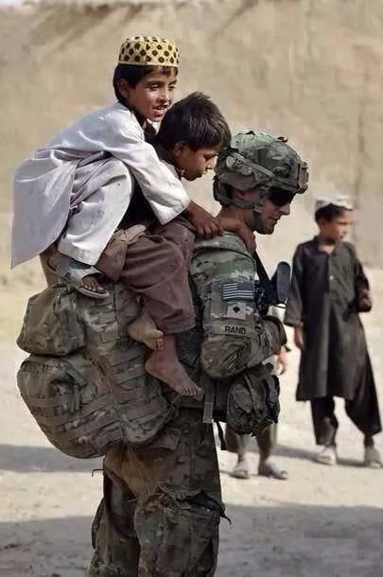

Q: How has the modern soldier been represented in the following image?
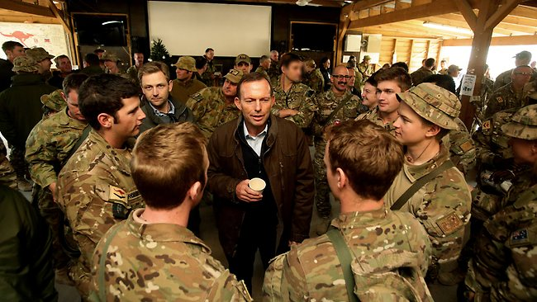

TONY Abbott has paid a surprise pre-Christmas visit to Australian troops in southern Afghanistan to thank them for their ongoing mission
13th December 2012

How has image B been constructed to present specific ideas?
Image B has been deliberately constructed to challenge the stereotype of a soldier and highlights the humanity of military personnel. This is clearly done through the successful visual devices of facialexpressions/body language, setting and written text. Whilst the male soldier is clearly identified through his clothing as being part of the military, his proximity to the dog contrasts the idea of soldiers as being tough, hardened and merciless. The soldier’s facial expressions indicate his joy at being with the dog, who in turn has a wagging tongue and has jumped up to his master – all indicators of a happy and friendly dog. The soldier’s posture is relaxed and his hands extend to support the animal as it jumps up to greet him. The coexistence of the two reminds the viewer of the strong relationship that has formed between the soldier and the dog – something that would have taken time to create. This indicates that the soldier and the dog have a relationship outside of this image which further challenges the notion of soldiers being heartless.
The setting of the image is in stark contrast to the relationship that is in focus. The harsh desert with limited greenery is juxtaposed against the relationship which is full of life and energy. This is a deliberate attempt to highlight the strength of the relationship amidst an environment that is isolated and dull – a place where one would not expect to find life. The setting works symbolically to contrast the lifeless environment to a budding relationship between a dog and its master.
Finally, the “National Geographic” written text in the image reminds the viewer of the gravity of the image, perhaps as a reminder to the viewer of the humanity of military personnel. The viewer understands the idea that National Geographic only publishes images that are worthy of their status, reminding the viewer that this cleverly constructed image is a deliberate attempt to highlight the humanity in soldiers.
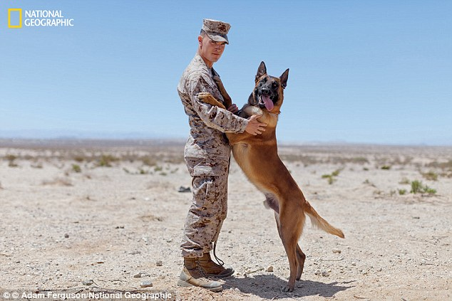
KEY
Purple – setting argument
Red – Point
Blue – describe/evidence
Yellow – Analysis

