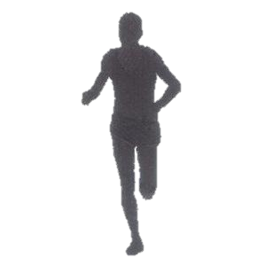



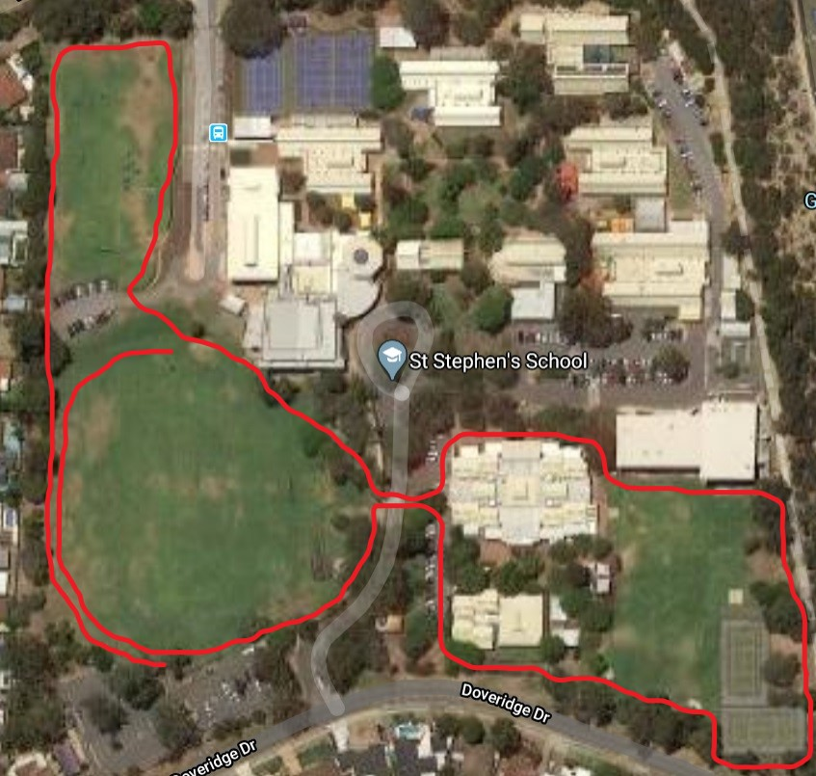

**YEAR 3 COURSE – 1500m**

**FINISH**

**START**