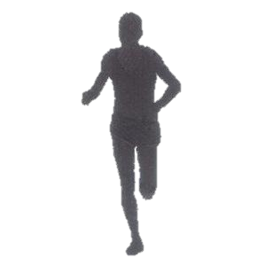



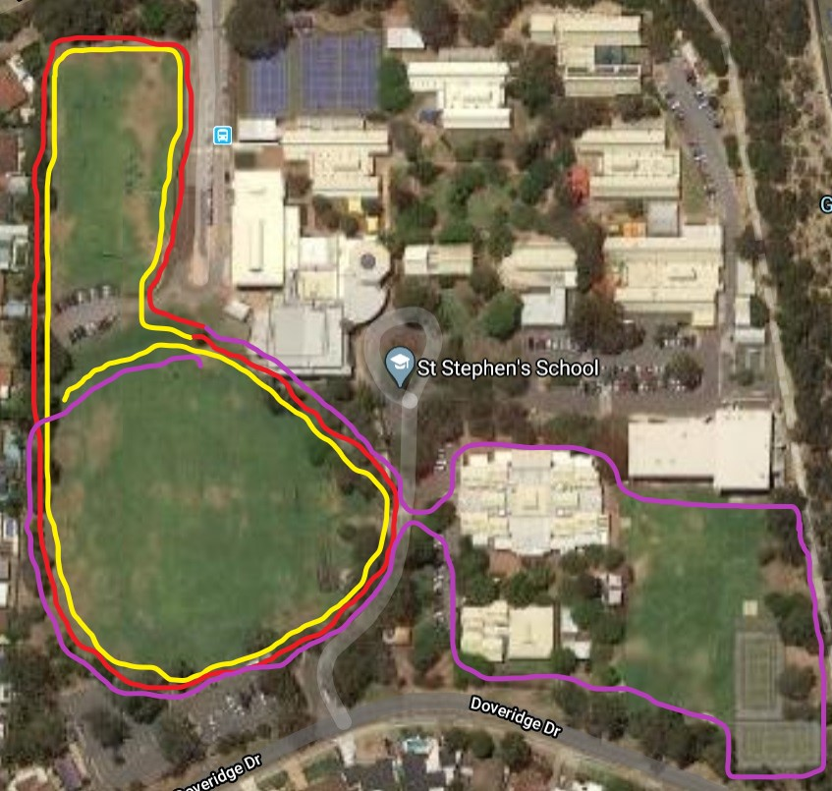

**Students in year 5 and 6 will complete two laps of Hamer oval and top oval before heading over to Primary and then back again.**

**FINISH**

**START**

**YEAR 5 and 6 Course – 2500m**