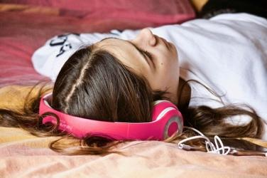
SEEKING CONFIDENT TEENAGERS

At Macquarie University, we are conducting an exciting online study investigating body image in Australian adolescents. To help us do this, we need to learn from adolescents who are not anxious or concerned about their appearance.

We are seeking parents and their confident teenagers 12 to 17 years to participate in our online study. To thank you for your time and involvement in the study, you will receive a $30 gift voucher at the completion of your participation.
To find out more about this project, please contact bddproject@mq.edu.au

