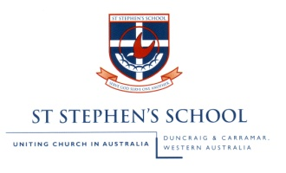
TASK 1b: Tourism Posters

Due Date: 2019 Weighting: 10%
Type of assessment – Responding

Task 2: Adopting the persona of a character, respond to the social environment and central tensions featured in one of the studied fictional texts.
Content focus:
- Consider the ways in which main ideas, values and supporting details are presented in fictional texts
- Manipulate language features such as tone, accent and vocabulary to influence responses
Weighting = 9%
Due = 2nd Dec. 2016 (T1, W7)
Content focus:
What you will need to do:
- Prepare an oral recording of 2-3 minutes which explains your reasons for choosing the particular visual and written elements of your poster
- Outline your target audience and how your posters apply to that target audience
- Explain what you like about the poster
- Provide some ideas of improvements you could have made for your poster.
- Explain how your posters fit the AIDA formula used for marketing.
- Hand in a written explanation of the above as well. – 250 words minimum

Marking Key | Marks
Engages with the question | 1–5
Effectively answers all aspects of the task.
Expression | 1–5
Speaks fluently with a good control of vocabulary, tone and pace.
Structure | 1–10
Develops a coherent structure that:
Names and describes a target audience
Explains how they have used the AIDA formula
Explains choices of written and visual language used.
Concludes with what improvements could be made
Stays within the time period.
Text structures and language features | 1–10
Analyses how a breadth of visual and written elements communicate ideas and provide a representation of Australia.
Total | /30

Task 2: Adopting the persona of a character, respond to the social environment and central tensions featured in one of the studied fictional texts.
Content focus:
- Consider the ways in which main ideas, values and supporting details are presented in fictional texts
- Manipulate language features such as tone, accent and vocabulary to influence responses
Weighting = 9%
Due = 2nd Dec. 2016 (T1, W7)

