Year 11 English General
Community Service Announcements (CSA)

Task 4:
Create a range of text types presenting Community Service Announcement Commercials and complete a journal that provides research data and that analyses each text.
Each text type must promote a different Community Service.
- Create ONE written 30 second radio community service announcement (script)
- Create ONE recorded 30 second radio community service announcement
- Create ONE community service announcement poster
- Create ONE community service 60 second video

- Complete a journal that provides research data and that analyses each text.

Exemplar community service:- Research of Wheeled chair sports
Radio
https://www.tandfonline.com/doi/abs/10.1080/19346182.2012.663531
Supporting the paralympic athlete: focus on wheeled sports
The Ethics of Performance-Enhancing Technology in Sport
Paralympic sport: an emerging area for research and consultancy in sports biomechanics
Wheel -Chair sports
Are you a future para-athlete like our present champion from Perth, Madison de Rosario, or are you the next Louise Savage or Kurt Fearnley?
Sports played in wheelchairs are games played by persons with a disability, including physical and intellectual disabilities. They are sometimes referred to as adapted sports.
Just because you are in a wheelchair doesn't mean you can't enjoy the competitiveness and just all-around fun that playing sports offers you.
There are a wide range of sports that have been adapted to be played by people with varying types of disability, as well as several that are unique to disabled sports.
Sport plays a vital role in the rehabilitation of those with disabilities and can often be a catalyst for increased confidence and self-esteem.
More and more wheelchair users are playing sports every day - some even on a professional level.
There are several wheelchair sports associations and gaming opportunities for your wheelchair and you - all you have to do is educate yourself regarding playing the game safely and find out what options you have.
To assist in sport playing in wheelchairs accessories are available and include belts and harnesses, gloves, bags for carrying items, drink holders and specialty back supports.
Rugby, basketball, hockey, fencing as well as athletics are undertaken by many

Wheelchair Sports WA is much more than just a sports club. We offer a range of social, recreational and sporting opportunities to our members to encourage them to live fuller, healthier and more active lifestyles.

We welcome anyone who has some form of physical disability and their families, friends and supporters to join the Wheelchair Sports WA family.
Wheelchair Sports WA is associated with over 15 sports and has something suited for anyone with any physical disability, whether they are looking to get competitive or just want to play socially. If sport isn't for you, then there are plenty of recreational and social activities such as fish trips and quiz nights to get involved with. If you have any questions or want to get involved, then please do not hesitate to contact the WSWA office.

Location: Herb Graham Recreation Centre, Mirrabooka, 6061 & Various other locations depending on desired activities
P: Charlie Maughan on (08) 6143 5800
W: www.wheelchairsportswa.org.au & www.facebook.com/wheelchairsportswa

Poster
Kurt Fearnley; retired para-athlete – flag bearer at Gold Coast games - profile
https://www.bing.com/images/search?q=kurt+fearnley&qpvt=kurt+fearnley&FORM=IQFRML
www.celebrityspeakers.com.au/louise-sauvage/

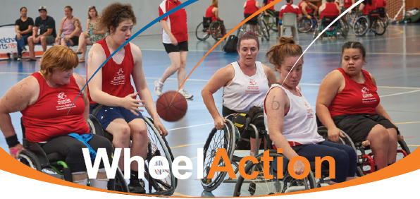

Video
Video news clips/interviews with … past & present/future athletes
https://thewest.com.au/news/australia/wa-wheelchair-athletes-fashion-ad-first-in-new-target-campaign-ng-ya-118142
https://www.smh.com.au/sport/athletics/australian-de-rozario-delights-in-london-marathon-triumph-20180423-p4zb3w.html

