Australia's heatwave: a taste of things to come
BY:TIM FLANNERY | JANUARY-19-2013

Unprecedented heat and bushfires are a wake-up call, says Tim Flannery, but we're running out of time.
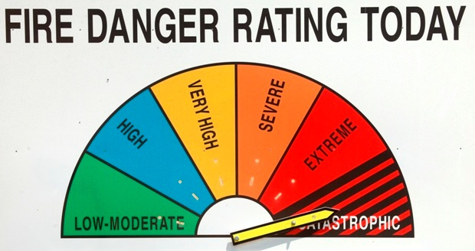

Tim Flannery sees possible catastrophe in Australia's future. (Credit: AAP/Lukas Coch)

THIS SUMMER, LIFE here in Australia has resembled a compulsory and very unpleasant game of Russian roulette. A pool of hot air more than 1600km wide formed across the inland. It covered much of the continent, and has proved astonishingly persistent.
Periodically, low pressure systems spill the heat towards the coast, where most Australians live. At Christmas it was Perth. Then the heat struck Adelaide, followed by Tasmania, Victoria, and southern New South Wales and Canberra. The second weekend in January, it was southern Queensland and northern New South Wales that faced the gun. On Friday, Sydney experienced its hottest day ever recorded, with a high of 45.8ºC.
And with every heatwave, the incidences of bushfires and heat-related deaths and injuries spike.
Australians are used to hot summers. We normally love them. But the conditions prevailing now are something new. Temperature records are being broken everywhere. At Leonora, in the Western Australian interior, it reached 49ºC two weeks ago – the national high – and just one record temperature among many. The nation's overall temperature record was set on 7 January. Then the following day that record was exceeded, by half a degree celsius.
Australia's shifting climate
The breaking of so many temperature records indicates that Australia's climate is shifting. This is supported by analysis of the long-term trend. Over the past 40 years we've seen a decline in the number of very cold days, and the occurrence of many more very hot days.
All of this was predicted by climate scientists decades ago, and is consistent with the increasing greenhouse gas concentration in the atmosphere
The new conditions have seen the Bureau of Meteorology add two new colour categories to Australia's weather prediction maps. Temperatures of 48-50ºC used to be the highest, and where such extremes were anticipated, the weather map was marked black.
Over the last few weeks, purple patches have begun to appear on some maps. They mark temperatures above 50ºC. Pink, which is yet to be deployed, will denote temperatures above 52ºC.
Climate extremes have a way of stacking up to produce unpleasant consequences. Two years ago, the ocean temperature off northwestern Australia reached a record high, and evaporation of the warm seawater led to Australia's wettest year on record. This was followed, in central Australia, by the longest period without rain on record. The vegetation that had thrived in the wet now lies dried and curing, a perfect fuel for fires.
Catastrophic bushfire risk
With abundant fuel and increased temperatures, the nature of bushfires is changing. Australians have long rated fire risk on the MacArthur index. On it, a rating of 100 – the conditions that prevailed in the lead-up to the devastating 1939 bushfires – represents "extreme" risk.
But after the 2009 fires a new level of risk was required. "Catastrophic" represents a risk rating above 100. Under such conditions fires behave very differently. The Black Saturday fires of 2009, which killed 173 people, were rated at between 120 and 190. They spread so fast, and burned so hot, that the communities they advanced upon were utterly helpless.
The superheated air currently monstering the continent is fickle. Earlier in the month, Sydneysiders watched in relative thermal comfort as those living just 100km to the south endured scorching heat, blustering winds, and unstoppable fires.
The unprecedented conditions of recent weeks have seen many Australians rethinking their attitude to climate change.
A good friend of mine farms just outside Canberra. A few years ago the drought was so severe that his 300 year-old gum trees died of thirst. Then the rains came on so violently that they stripped the precious topsoil, filling his dams with mud and sheep droppings. This week he watched as his cousin's property at Yass was reduced to ashes.
Reducing greenhouse gas emissions
When I called he was trying to secure his own historic homestead and outbuildings from fire. He asked me if I thought the family would still be farming the area 50 years from now. All I could say was that it depended upon how quickly Australia, and the world, reduced their greenhouse gas emissions.
Australia's average temperature has increased by just 0.9 of a degree celsius over the past century. Within the next 90 years we're on track to warm by at least another three degrees. Having seen what 0.9 of a degree has done to heatwaves and fire extremes, I dread to think about the kind of country my grandchildren will live in.
Even our best agricultural land will be under threat if that future is realised. And large parts of the continent will be uninhabitable, not just by humans, but by Australia's spectacular biodiversity as well.
The extreme conditions have once again raised the political heat around climate change. The Greens party condoned an anti-coal activist who created a false press release claiming that the ANZ bank had withdrawn support for a major coal project, causing its share price to plunge. Meanwhile the acting leader of the opposition, Warren Truss, said it was simplistic to link the hot spell to climate change, and "utterly simplistic to suggest that we have these fires because of climate change".
Race against time in Australia
Australia is the world's largest coal exporter, and the mining lobby is exceptionally strong. As calls to combat climate change have increased, the miners have argued that "mum and dad investors" will lose out if any effort is made to reduce the export or use of fossil fuels.
But the smart money is no longer backing fossil fuels. In South Australia, wind energy has gone from 1% to 26% of the mix in just seven years, and nationally solar panel installations are 13 years ahead of official projections. Last year, in fact, Australia led the world in terms of number of individual solar installations.
And finally, with a carbon price in place, Australia's emissions curve is beginning to flatten out. Despite these efforts, Australians are already enduring the kind of conditions they'd hoped to avoid if strong, early action had been taken. Now, more than ever, we're in a race against time to avoid a truly catastrophic outcome.
Professor Tim Flannery is a scientist at Macquarie University, a writer, government advisor and former Australian of the Year. This opinion piece was first published by the Guardian newspaper.

