**NRA history offers clues that American gun laws can change**

Michael Ondaatje

[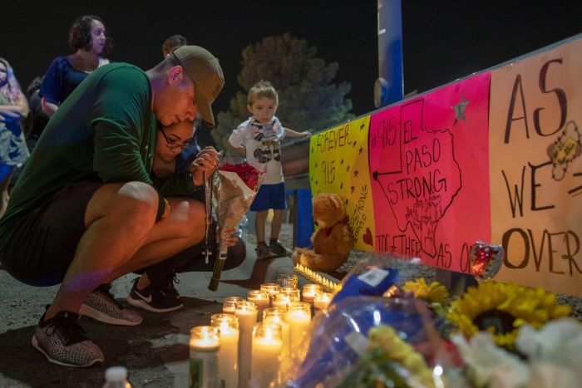](https://www.abc.net.au/news/2019-08-06/men-bends-over-at-makeshift-memorial-to-el-paso-victims/11388852)

**Many of today's gun rights activists see themselves as heirs to the American Revolution, vigorously defending the Constitution against 'left-wing forces' seeking to restrict individual liberty broadly, and the right of the people to bear arms specifically.**

Guns are a fundamental part of the American experience in the eyes of many US citizens and the right to own a gun is viewed as connected to core American values like individualism and personal liberty.

Yet since 1960 nearly 1.5 million Americans have died from guns (homicides, suicides and accidents) and "everyday" gun violence has become so normalised in the US that in the aftermath of two mass shootings last weekend the only flicker of surprise was that they occurred so close together.

Every year twice as many Americans lose their lives to guns than die in terrorist attacks around the world.

Many see reducing gun violence as a moral imperative. But doing this won't be easy, given what we know about American history.

**The NRA once promoted gun safety**

The National Rifle Association is the major gun rights advocacy organisation in America, with a membership of 5 million and an annual budget of more than $300 million.

Since the early 1970s, the NRA has been remarkably successful at promoting the view that gun regulation of any kind threatens the freedom of American citizens and will lead to 'tyrannical' government.

The NRA was founded in 1871 and for its first 100 years was concerned primarily with promoting responsible gun ownership and training hunters and Boy Scouts to shoot safely.

In fact, the NRA even backed gun control: supporting the 1934 National Firearms Act, America's first federal gun control legislation, and the subsequent 1938 Gun Control Act.

Then-president of the NRA, Karl T Frederick, said at the time that he had never believed in the general practice of carrying weapons: "I think it should be sharply restricted and only under licences".

When President John F Kennedy was shot and killed in 1963 his successor, Lyndon B Johnson, moved to restrict interstate and mail order gun sales. The NRA supported the move.

**So what has changed?**

In many respects, the gun "debate" reflects the wider polarisation in US political culture.

It is also a function of a moment in history.

By the mid-1970s faith in government was at an all-time low and there was heightened paranoia that the government was plotting to restrict private gun ownership.

There was also a wider conservative backlash against liberalism and the "excesses" of the 1960s.

Conservative Americans — who had seen militant Black Panthers brandishing weapons — responded by raising the stakes and buying more guns.

The NRA became divided between newly politicised lobbyists and traditionalists interested in sport and safety. The organisation itself became an ideological battleground.

In 1975 the NRA established its first lobbying arm, the Institute for Legislative Action (ILA).

The battle reached a peak at the NRA's 1977 Ohio conference when a group of delegates opposed to gun control dressed in orange hunting caps and took over the conference, demanding more aggressive leadership to protect the interests of gun owners.

Known as the "[Revolt of Cincinnati](https://www.washingtonpost.com/politics/how-nras-true-believers-converted-a-marksmanship-group-into-a-mighty-gun-lobby/2013/01/12/51c62288-59b9-11e2-88d0-c4cf65c3ad15_story.html?utm_term=.e1060cf05913)", the takeover has gone down in the folklore of the American gun lobby as a principled fight for freedom.

.

**Gun ownership became political**

Soon after, gun lobbyists began to talk as if unrestricted gun ownership had always been a constitutional right.

The NRA rode a wave of popular anti-government sentiment that propelled the NRA to a powerful position in American politics.

Today, the NRA is a formidable outfit, firmly wedded to an anti-gun control agenda.

It donated $30 million to Donald Trump's 2016 election campaign and, as president, he has signalled that the NRA has ["a true friend"](https://www.pbs.org/newshour/politics/trump-nra-friend-white-house) in the White House. He is the first sitting president to address an NRA convention since Ronald Reagan in 1983.

**There are signs of hope**

Gun ownership in the US is [dropping](https://www.washingtonpost.com/news/wonk/wp/2016/06/29/american-gun-ownership-is-now-at-a-30-year-low/?noredirect=on) significantly.

The survivor-led social movement that emerged in the aftermath of the [Parkland massacre](https://time.com/parkland-high-school-shooting-vigil/) — in which 17 students and teachers were killed at a Florida high school — appeared to break through where previous protests failed.

And as American society changes — due to immigration, urbanisation and growing numbers completing higher education — gun ownership's historical links to the American Revolution or the crime of the 1960s will have less influence.

This will likely mean stronger support for gun control in the years ahead.

Knowing how the lobbying environment changed once, gives some hope that it can change again.

**Professor Michael Ondaatje is Pro Vice-Chancellor (Arts and Academic Culture) at Australian Catholic University and a Professor of History, specialising in the United States.**

**Feature article reproduced from the ABC News website, 7th August 2019.**

**https://www.abc.net.au/news/2019-08-07/nra-history-offers-clues-that-american-gun-laws-can-change/11388638?section=analysis**