https://www.realestate.com.au/advice/a-first-timers-guide-to-moving-out-on-your-own/
A first timer’s guide to moving out on your own
Emma Sorensen
Whether you’re 18, 21, 30, or 50 – there will probably come a time in your life when you decide to move out of home and go it alone in the big wide world.
Regardless of when it happens, or why, you’ll probably feel the same excitement and nerves in equal measure.
Here are some tips to help you fly out of the nest and not flee back again just as fast.

Consider your decision to move
There are many reasons to move out – maybe it’s your decision, maybe it is someone else’s, maybe it is necessity, maybe it is just time.
No matter why you’re moving on think about it calmly. Are you ready to live independently? What are your options?
And if it is your decision, are you moving out for the right reasons? Don’t make a rash decision that could see you needing to move back home again soon, and make sure you consider all the avenues available to you.
If you’re testing the waters of moving out on your own, a share house could be a good option.

Find the right place
Whether you’re buying, sharing or renting, you’ll need to work out what kind of property best suits you and your lifestyle.
Ask yourself some serious questions. Can you live alone or is a flat share the best option? Will you be happy in a grungy share house or is a slick inner-city pad more your style? What can you actually afford? And where?
If you’re testing the waters maybe a room in a share house, rather than taking the lease in your own name, is best to start with.
Start your search online, but don’t stop there: you can’t tell everything from photos, so make sure you attend several open houses to get a sense of what your budget really buys you.
And if you’re looking for someone to live with, check out our tips for finding the perfect flatmate.

Finances
Leaving home is expensive, and it doesn’t take long for bad budgeting to lead to financial hardship, so you need to plan ahead.
A Melbourne University study found some young Australians were going without food and borrowing money to survive when they moved out of home. Avoid this situation by calculating your known monthly income then planning a monthly budget for food, bills, transport, entertainment and extras.
Always pay any bills and rent on time to avoid a bad credit rating. If you want to buy a home later on, someone will be looking at how you managed financially.
Don’t forget that when setting up or moving house there are also establishment fees such as a rental bond (usually a month’s rent in advance), phone, cable TV, gas, electricity or internet connection fees, as well as the set up costs of furnishing rooms or equipping a kitchen.
It’s also smart to take out home contents insurance, just in case.
No matter how much, or how little money you have, managing your money well is the best foundation to living independently and this will have flow on effects to all aspects of your life.
Chores
Moving out gives you independence, freedom and adventure, but it all comes with added responsibilities.
Without sounding like mum and dad, try to keep on top of the chores like cleaning, cooking, laundry, and taking the bins out. You don’t want to fall into the cliché of being a typical first time out of home slob.
Keeping up with chores will make your life easier in the long run.
Look after yourself: if you’re used to having meals cooked for you at home make sure you get into a rhythm of cooking yourself, rather than skipping meals or relying on take away every night (that’ll eat into your budget too).

Communicate
Communication is the key to any relationship and it is no different for your flatmates or partner (assuming you are not living alone).
Avoid conflict by setting ground rules, being open and respecting others’ opinions (including any opinions they have on the way you live.
Living independently for the first time you’ll face your share of surprises, including the challenges of living with others. It’s common for this to make people a bit nervous or unsettled.
Remember you’re not alone, and work on expressing how you’re feeling to avoid misunderstandings.

Hide a spare key
There’s nothing worse than the surprise of an after-hours call out fee for a locksmith, so give someone you trust a spare key to your house. No, don’t hide it in the garden.

Keep in touch
No matter how old you are, if it’s your first time out of home your parents or guardians will probably miss you. Give them a call from time to time or go home for a meal. Just try not to land on the doorstep with the washing too often.

Practice
If you’re thinking about moving out, see if you can trial it for a while to test your skills at budgeting and housework. Perhaps you could stay with a friend. Or get a short-term rental for a few months.
Another idea is to get your parents to let you ‘run the house’ for a month or two and be responsible for as much as you practically can.

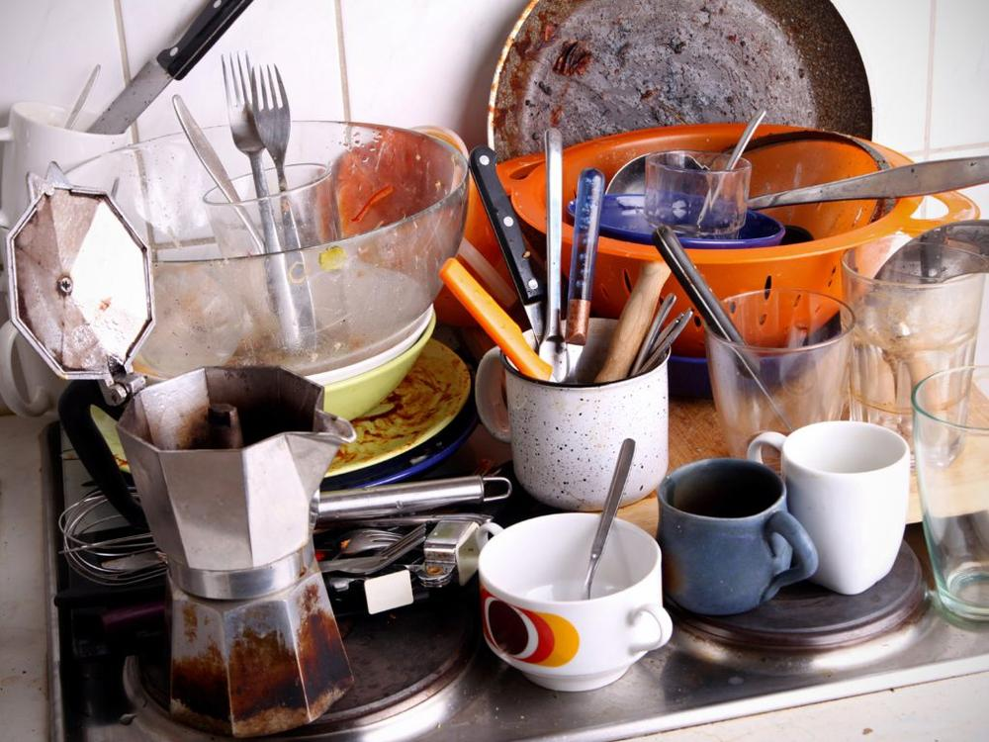
A short-term rental can be a good option to trialling moving out on your own.
This will give you a better idea of what’s involved and may give them a chance to put their feet up.
If you don’t do your own washing, now’s the time to start. Make sure you can do all the things you’ll need to do when you step out.

Ask for help
Moving out for the first time can be daunting, and there’s a lot to get on top of. Don’t be too proud to ask for help if you find yourself under financial or emotional stress or if you have any other kind of trouble.
While your parents might be there for you, not everyone who moves out can move back home or ask their parents for help in times of trouble so make sure you’re familiar with the community or government organisations that can lend a hand. These vary depending on which location you’re in, but include:

