

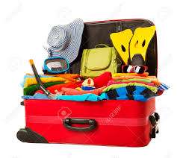**INDONESIAN SERVICE TOUR**

**July 8 – July 16, 2019**

**Packing List**

**Clothing**

8x Underwear

8x socks

8x T-shirts (covered shoulders and covered tummy)

8x Long shorts (down to the knee is culturally appropriate, school shorts are not appropriate when out and about) or long light-weight pants or long skirts

1x Long sleeve shirt (for evening and/or in AC on plane)

1x respectful clothes for church (shirt with a collar, not a t-shirt and longer pants or longer skirt)

1x Rashie top (long sleeved is best, short sleeved ok)

1x swimmers (boardshorts are a good idea, more culturally appropriate than a bikini or one piece)

Note: There is a laundry near the hotel where we can deposit our laundry to be washed/dried/ironed for us for just a few dollars. This cultural experience is something we can do mid-way through the trip. Make sure you bring at least 5 sets of clothes if you plan on getting your clothes washed there.

**Accessories**

1x Hat (school hat is suitable) 1x goggles for pool

1x sunglasses 1x sunscreen

1x beach towel 1x hand sanitizer

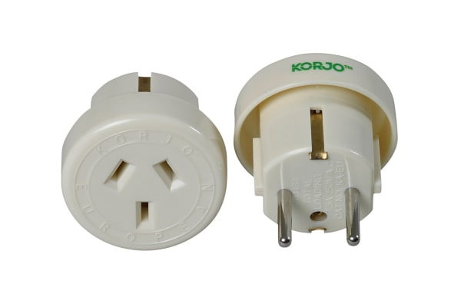1x mosquito repellent

1x adapter for Aussie electronics

1x phone charger (only if required)

1x earphones & phone (optional)

1x day bag / backpack 1x camera (optional)

2x canvas shopping bags (so we don’t have to use plastic ones)

**Footwear**

1x thongs for wearing to the beach or around the hotel pool

1x reef shoes for wearing at Single Fin Beach and Hidden Canyon

1x old sports shoes that can be worn at Suwung Rubbish Tip

1x usual sports shoes that can be worn on most days when walking the streets of Bali (closed in shoes)

1x shoes for church

**Toiletries**

(Hotel provides basic shampoo, conditioner and soap.)

1x toothbrush 1x toothpaste 1x pkt face wipes

1x sanitary products (tampons aren’t readily available in Indonesia but pads are) 1x sunscreen 1x tissues

1x roll-on deodorant (no aerosols allowed on the plane)

1x shampoo 1x conditioner 1x hair brush