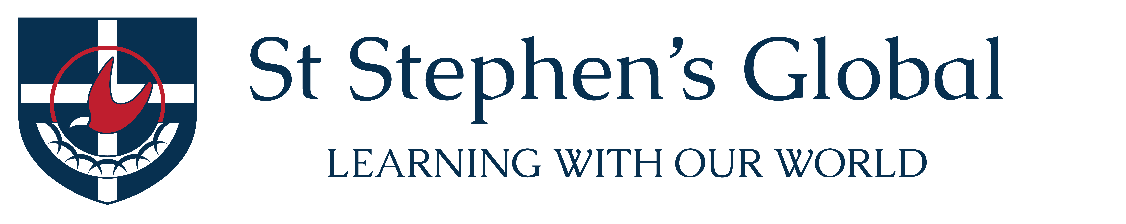

Parent Consent Form – 2018 South Africa Service Learning Tour

Dear Parents/Guardians and Students,
The following consent form applies to the registration for the St Stephen’s Global South Africa Service Learning Tour 2018.
Please review and complete the following prior to giving consent for your child to attend this tour:
- South Africa Service Learning Tour Trip Agreement
- Please complete the separate Medical Consent Form and return it with this Parent Consent Form to the supervising tour teachers by the due date.
- Please note the tour cost of $3900 and the payment schedule provided in the Trip Agreement. The first payment of $1600 is due by Monday, the 24th of July 2017 and should be paid to Accounts using the electronic link provided on the blog or in the Trip Agreement.

Parent/Guardian
I have read, understood and agreed with the St Stephen’s Global South Africa Service Learning Tour 2018 documents/information mentioned above and give consent for

______________________________________ (student full name) to attend the tour.

Signed: _____________________________________________________________(parent/guardian)

Parent/guardian name: ______________________________________________(please print clearly)

Date: ____________________

Please return this signed form to the tour staff by Monday, the 24th of July.

