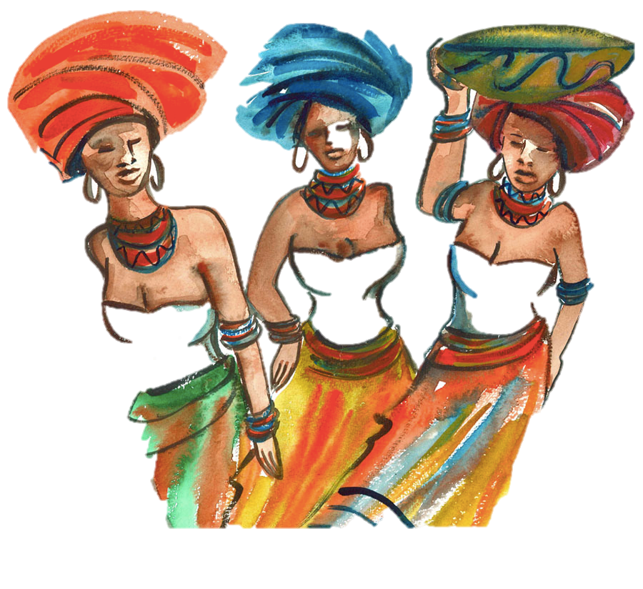
Cultural Immersion –

African Dialects

Xhosa

1) Watch ‘Clicks’ Lesson: https://www.youtube.com/watch?v=YlocO29uud4

X (‘horse’ sound)

C (‘shame click’)

Q (door knocking click)

Trying saying these with vowels

2) Listen to ‘The Click Song’

https://www.youtube.com/watch?v=Qg4Fp-A7IRw

3) Learn ‘Shosholoza’ South Africa’s second anthem

https://www.youtube.com/watch?v=2aFlQS4k3wo

Lyrics:
Shosholoza
Kulezo ntaba
Stimela siphume South Africa
Kulezo ntaba
Stimela siphume South Africa
Wen' uyabaleka
Kulezo ntaba
Stimela siphume South Africa

A rough translation:
Go forward
Go forward
from those mountains
on this train from South Africa
Go forward
Go forward
You are running away
You are running away
from those mountains
on this train from South Africa

